**Installing Prometheus**

Installing Grafana

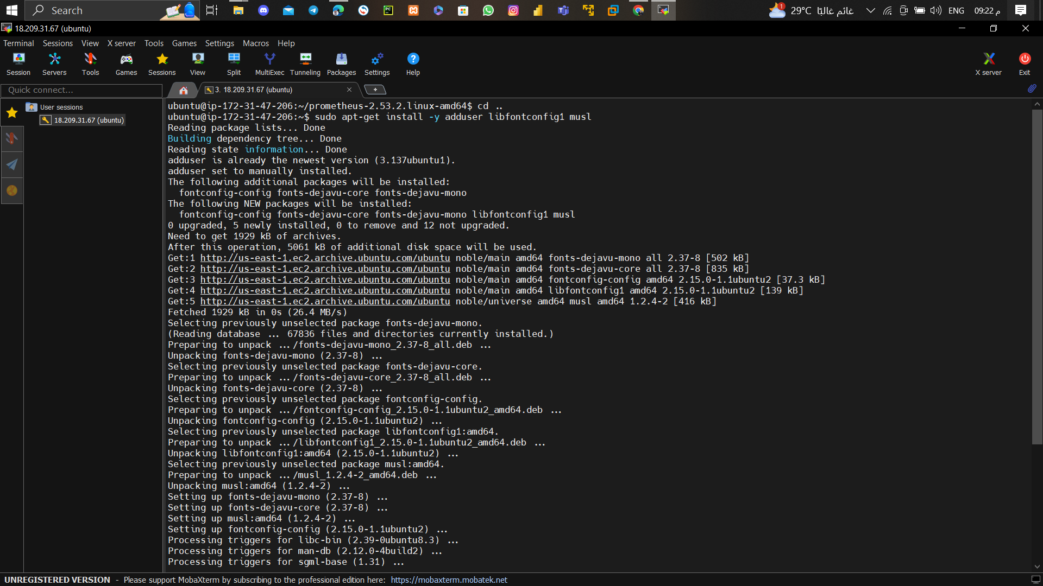

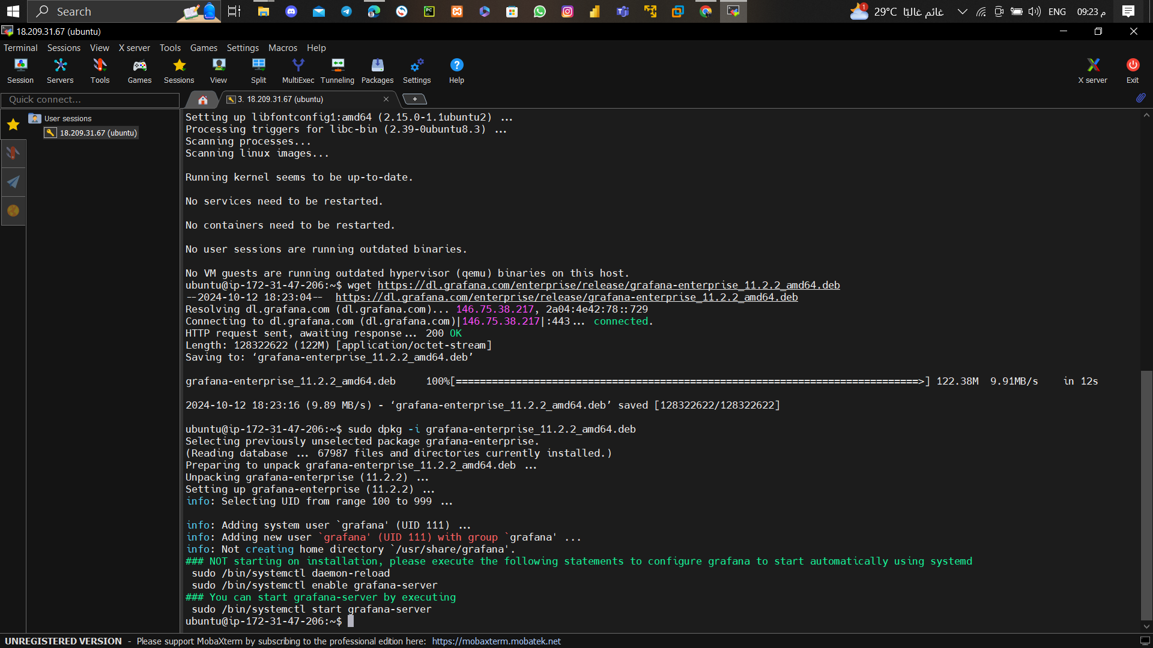

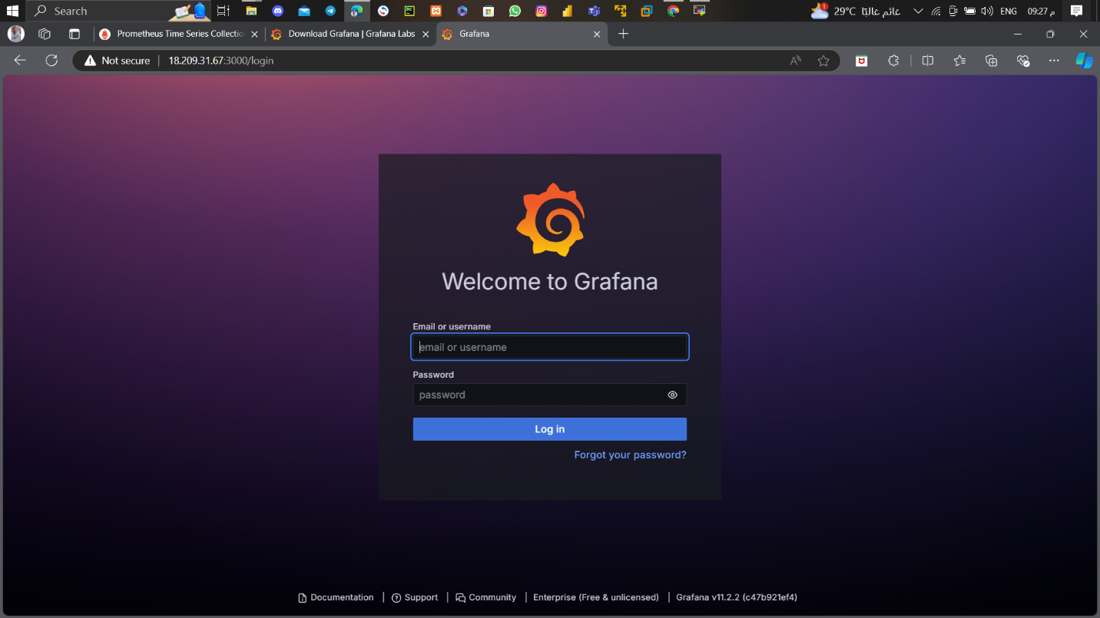

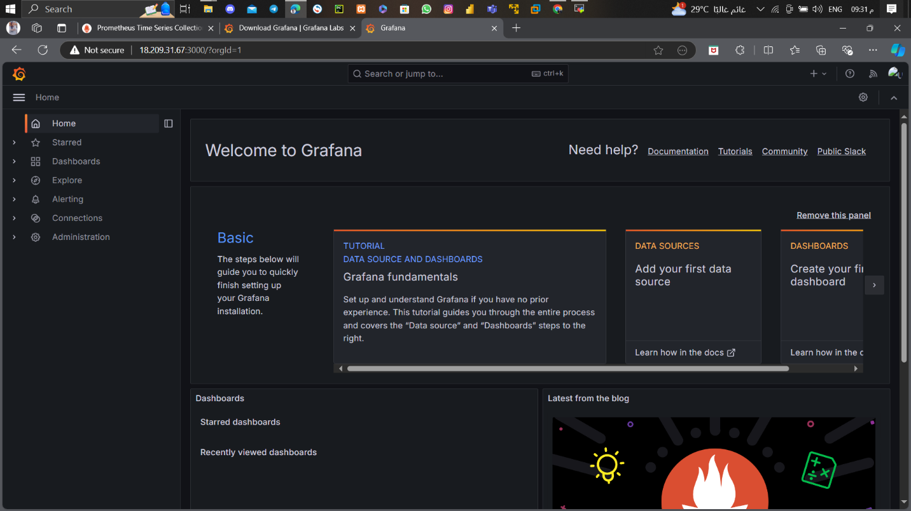

Installing Black box exporter

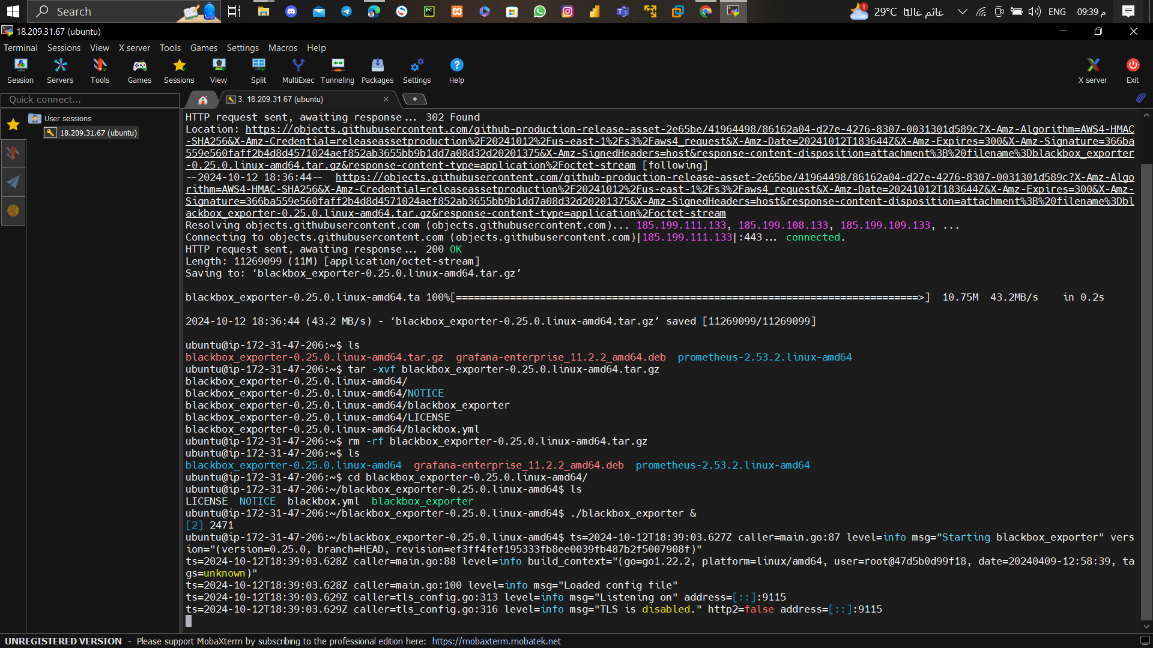

Adding Prometheus as a Data Source to Grafana

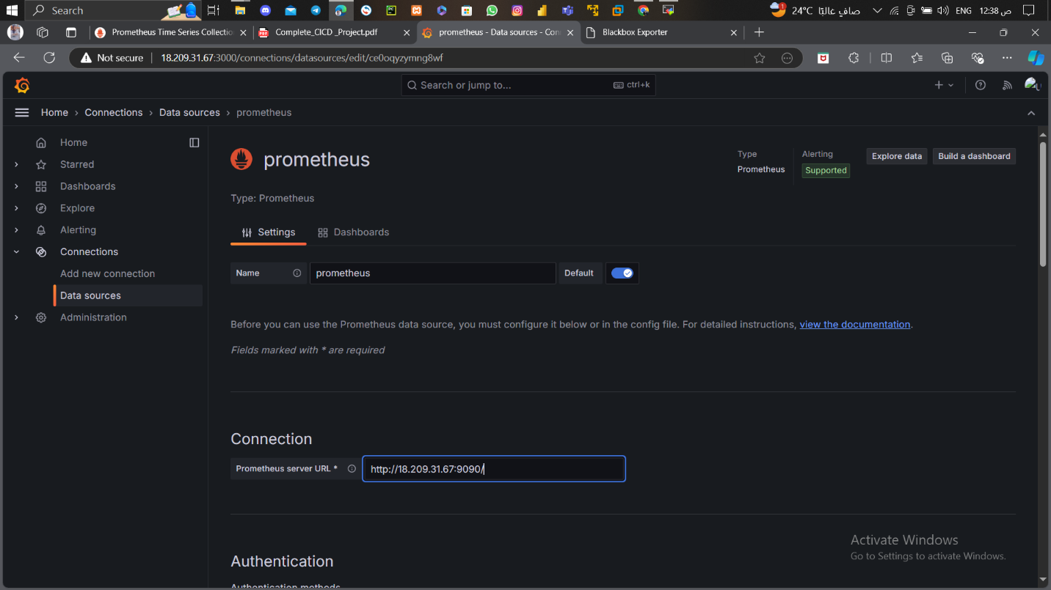

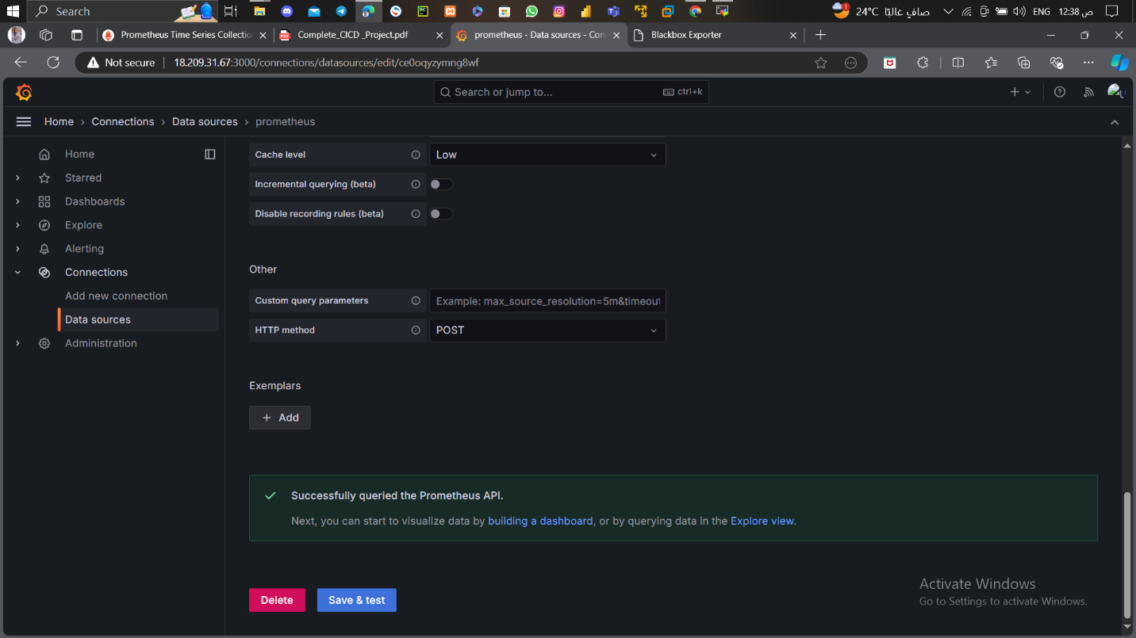

Monitoring the website

